Shabbos Stories for
Rosh hashanah 5782
Volume 13A, Issue 1 1-2 Tishrei/ September 7-8 2021
Printed L’illuy nishmas Nechama bas R’ Noach, a”h

For a free subscription, please forward your request to keren18@juno.com

Story #1188
The Shofar of the
Cracked Bell
By Chaya Halberstam-Evers
From the desk of Yerachmiel Tilles
editor@ascentofsafed.com

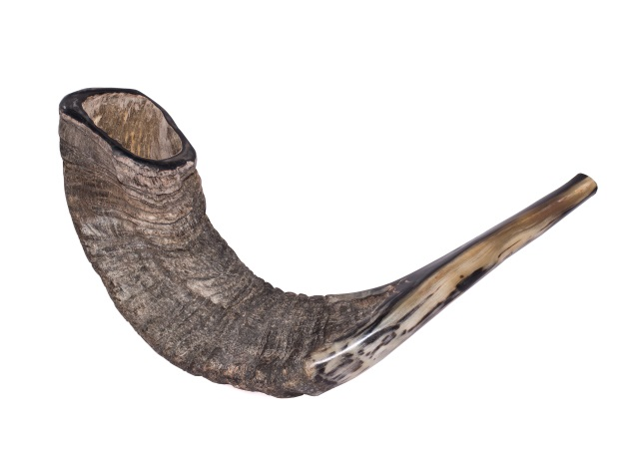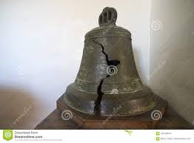

It was the end of a Siberian summer, in 1940. My grandfather, Rabbi Meir Halberstam, a young boy of 13 years old at the time, was imprisoned in a work camp together with his grandfather, the Rebbe of Zhemigrod, Rabbi Sinai Halberstam.
Young Meir had moved with his family to Palestine to settle in the holy city of Jerusalem in 1936, before the war had broken out. In honor of his upcoming Bar Mitzvah, his father sent him on a boat back to Poland where he would be able to celebrate this auspicious day in the chasidic court of his holy grandfather.
Upon his arrival in Poland, the rumble of war was approaching. Disciples, family, and community members were all scrambling to save their lives. With the Nazis at their heels, young Meir escaped with his Grandfather and immediate family to Russia. At last they were safe from the Nazi enemies, or so they thought.
Due to the large amount of Polish refugees in Russia, the Russian government seized the opportunity to use them as slaves. Charging them as enemies of the state since they had Polish passports, young Meir and his Grandfather's whole entourage were sentenced to heavy slave labor in the cold Siberian plains.

The Mild Siberian Summer Had Ended
Rosh Hashana was approaching, and the mild Siberian summer had ended, ushering in the tundra-like winds and cold. Young Meir noticed that with each passing day, his Grandfather, the Rebbe of Zmigrad was becoming more and more depressed. “How will we blow the shofar?” he cried. Although he had the holy shofar that had been passed down from his ancestors, the thought of being caught blowing it by the evil Russian guards, brought dread to his very being.
It was two nights before Rosh Hashana, and young Meir devised a daring plan. He awoke in the middle of the night, and wrapped cloth around his hands and feet in order to muffle any noise he would make. From his window, he watched the wild guards drinking and dancing late into the night. He waited until they were all stooped over in a drunken sleep and quietly trudged through the wind and cold to the front of the work camp, where the giant camp bell stood.
He looked to all sides to make sure he was unobserved, then climbed up a very high post until he reached the top of the bell. With all his might he unraveled the rope holding the bell and watched the entire bell come crashing to the ground, where it shattered into many small bits and pieces. He then descended the post and quietly returned to his barrack.

There Was an Uproar in the Camp
The next morning there was an uproar in the camp. Upon awakening, the guards saw the broken bell and realized that they would have a problem waking all the prisoners in time. It would take weeks until they would be able to get a new bell.
Young Meir then shared with his grandfather the brave mission he had done the previous night and whispered his plan.
By the time all the prisoners were up, the guards where quite angry and looking for someone to blame. Instead, young Meir’s uncle came forward and related to the head commander that he had an old shepherd’s horn that his father would gladly blow each morning to wake the prisoners until they received a new bell. Upon hearing this, the commander ordered him to bring the horn at once.
The Rebbe arrived, shofar in hand, and began to blow long notes. “Let me blow it” yelled the commander, grabbing it out of the Rebbe’s hands.
The commander took the shofar in his hands and brought it to his mouth, but no matter how hard he blew, no sound came out. It was at this moment of frustration that young Meir’s uncle advised the commander to let his Father blow it, since he was a “professional” horn blower. The commander then appointed the Rebbe as the official waker, who would be responsible to wake the prisoners each morning until a new bell was mounted.

Word Spred Quickly Throughout the Camp
Word spread quite quickly throughout the camp. All the Jewish prisoners knew that the Rebbe of Zmigrad, would blow his holy shofar the next morning, on Rosh Hashana. As the frosty morning beckoned, each prisoner was up early awaiting the sound of the shofar. The Rebbe wept as he blew the horn, the prisoners cried and prayed, and young Meir stood proudly as he watched the notes of the shofar break the darkness on that crisp Siberian morning. It was a shofar blowing that he never would forget.
My grandfather went through many more trials and hardships until he made it back to the shores of Israel (then Palestine) where he was welcomed and celebrated for the great miracles that happened to him.
Although I am a grandchild of Reb Meir Halberstam, I have only recently heard this story and it made a deep impression on me. Rosh Hashana is a very special time for our family. For me, it has always been a holiday of hope, and positivity, as we surely believe that the Al-mighty will embrace us and hold us, as he ushers us into a beautiful and sweet new year.

Recalling Her Grandfather’s Shofar
I try to think about the shofar that Zaidy (my grandfather) heard all those years ago on that cold Siberian morning, and the strength that it gave him and all the Jews who heard it. Perhaps this year, if I close my eyes and listen with my soul, I can internalize the sounds of the shofar and I will hear the sounds of faith, courage, and hope that it gave my grandfather.
~~~~~~~~~~~~~~
Source: Adapted and supplemented by Yerachmiel Tilles from an article on //chabad.org.
[Chaya Halberstam-Evers, is an educator and writer who lives with her husband and four children in Amsterdam.]
Connection: ROSH HASHANA
Biographical note: Rabbi Sinai Halberstam, the first Rebbe of Zhmigrod (1869-1941),was a son of Rabbi Boruch of Gorlitz, the 4th son of the Divrei Chaim, Rabbi Chaim Halberstam, founder of the Sanz dynasty. He died in the Omsk forest in Siberia, shortly after the events of the above story. Many of his male descendants became rebbes, including five grandsons who currently are Zhmigrod rebbes, in USA, Israel and Belgium.

Reprinted from the Rosh Hashanah 5781 email of KabbalaOnline.org, a project of Ascent of Safed.

12 People Who Left Their Mark on Rosh Hashanah
By Yehuda Altein

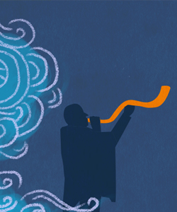

1. Adam
Rosh Hashanah, the head of the Jewish year, coincides with the sixth day of Creation—the day G-d created Adam, the first human. This is by no means coincidental. G-d specifically chose the birthday of the first human as the day that marks the Jewish New Year.
Why do we celebrate Rosh Hashanah on the anniversary of humankind, as opposed to the anniversary of the universe (six days earlier)? Because we—descendants of Adam—play an integral role in Creation. G-d created an incomplete world. It is up to us to use the coming year to fill in that gap, by instilling the world with Divinity and sanctity, one mitzvah at a time.

2. Eve (Chava)
Shortly after Adam was created from the dust of the earth, G-d determined that it was “not good for man to be alone”¹ and He created Eve (Chava), the first woman.
Rosh Hashanah is thus the anniversary of the creation of the first man, as well as the first woman. Ironically, while Eve was the paradigm of fertility (the very name Chava means “mother of all life”²), the other women on this list struggled to conceive.

3. Sarah
Our matriarch Sarah was barren for many years, until miraculously giving birth to Isaac at the age of 90. Our Sages tell us that it was on Rosh Hashanah that G-d “remembered” Sarah, resulting in Isaac’s conception.³
To recall this event, the Torah readingof the first day of Rosh Hashanah relates the story of Isaac’s birth and formative years.

4. Isaac
The Torah readingof the second day of Rosh Hashanah also features Isaac. It relates the story of the binding of Isaac, in the merit of which we pray that G-d judge us favorably and grant us a year of blessings. One detail of this story is the ram whose horns were tangled in a thicket—recalled by the shofar, made from a ram’s horn.⁴

5. Rachel
Rachel watched as her sister Leah bore Jacob one son after the next, while she remained barren. Finally, on Rosh Hashanah, Rachel was also remembered On High, resulting in her pregnancy with Joseph.⁵

6. Joseph
Years later, in the dramatic saga of Joseph’s life, Rosh Hashanah appears once again: It was the day he was released from prison, after being falsely accused of attempting to act immorally with the wife of his master Potiphar.⁶

7. Chana
Chana, mother of the prophet Samuel, is the third of the trio of barren women who were remembered on High on Rosh Hashanah.⁷ Some add that Rosh Hashanah was the day she offered a silent prayer in the Tabernacle in Shiloh, which the High Priest Eli mistook as a sign of intoxication.⁸
In commemoration, we read Chana’s story in the haftarahof the first day of Rosh Hashanah. This moving account underlines the power of prayer, demonstrating that if we invest our hearts and souls into our prayers, G-d will surely heed our requests.

8. Gedaliah
After Nebuchadnezzar destroyed the first Holy Temple in Jerusalem, he appointed the righteous Gedaliah, son of Ahikam, as the governor of the remaining Jews. Under his leadership, the small group of Jews began to recover and reclaim some sense of peace and security. However, this tranquility was not to last. On Rosh Hashanah, Gedaliah was slain by a jealous, treacherous Jew named Yishmael. Whoever survived the massacre fled to Egypt, and the last embers of Jewish life in the Land of Israel were extinguished.
To commemorate this sad milestone in our history, the day following Rosh Hashanah is kept as a fast day, known as Tzom Gedaliah.

9. Rabbi Amnon
One of the most soul-stirring prayers recited on Rosh Hashanah is Unetaneh Tokef. Its passages describe in vivid terms how all created beings pass before G-d on this day, and He decides the fate of each one. We are reassured, however, that even if negative occurrences are in store, “repentance, prayer, and charity revoke the evil of the decree.”
Who composed this haunting text?
Legend has it that it was composed by an early medieval scholar named Rabbi Amnon. After being punished by the local duke for refusing to renounce his faith and become a Christian, the crippled sage was brought to the synagogue on Rosh Hashanah, where he led the congregants in a newly composed addition to the High Holiday liturgy.
(Note: According to some versions of the account, Rabbi Amnon instructed the duke to amputate his legs, as punishment for his delay in responding to the duke’s offer. However, this version is problematic, as it is forbidden to willingly mutilate one’s body.⁹Also note that prayer appears to predate Rabbi Amnon.)

10. Rabbi Shimon the Great
The machzor—the prayer book used on the High Holidays—is replete with prayers exclusive to Rosh Hashanah (and Yom Kippur). Many of these prayers are known as piyutim (plural for piyut), liturgical compositions written in poetic style expressing the awesomeness of the day.
One of the first composers of piyutim was Rabbi Shimon the Great, a saintly tenth-century scholar from Germany. Many of the piyutim in the machzor were penned by him, and some of them include the Hebrew acrostic: Shimon bar (son of) Yitzchak.
Legend has it that one of Rabbi Shimon’s sons was kidnapped and raised as a Christian, rising in rank until he was appointed pope. On a mission to Rome on behalf of the Jewish community, Rabbi Shimon met with the pope and discovered his long-lost son, who subsequently returned to Judaism.
Read: Rosh Hashanah Services at a Glance

11. Jews in Concentration Camps and Soviet Gulags
Over the course of our history, Jews have taken the most extreme measures possible to mark this holy day and perform the sacred rite of blowing the shofar. Shofars were even smuggled into concentration camps and Soviet gulags and blown in secrecy, demonstrating that no one and nothing can destroy the indomitable Jewish spirit.

12. You!
Rosh Hashanah is a day of prayer, a time to ask the Almighty to grant us a year of peace, prosperity, and blessing. But it is also a joyous day, when we proclaim G-d King of the Universe. The Kabbalists teach that the continued existence of the universe depends on G-d’s desire for a world, a desire that is renewed when we accept His kingship anew each year on Rosh Hashanah. This is something that is up to each and every one of us, by hearing the shofar blasts and resolving to serve G-d over the upcoming year to the best of our ability. So the true hero of Rosh Hashanah is no one else but you.

FOOTNOTES
1. Genesis 2:18.
2. Genesis 2:23.
3. Rosh Hashanah 11a.
4. Genesis 22.
5. Ibid.
6. Ibid.
7. Ibid.
8. See comment of Chatam Sofer on Magen Avraham, Orach Chaim 581:15.
9. Likutei Sichot, vol. 29, p. 478.

Reprinted from the Rosh Hashanah 5781 email of Chabad.Org Magazine.

Get It in Writing

At an engagement celebration, the Kallah’s father was asked to put into writing the financial commitment that he promised to the young couple.
He did not want to do so, saying that they should take his word for it since he was a very dedicated father who always watched out for his children.
R’ Elchonon Wasserman, who was present at the time, immediately answered the Mechutan's claim based on the Tefila we say in Shmoneh Esrei during Aseres Yimei Teshuva.
“Zachreinu L'Chaim Melech Chafeitz BaChaim V'Chasveinu B'Sefer HaChaim.”
We have already asked Hashem to remember us for life, why do we then say to inscribe us in the book of life? Hashem does not forget and is equally devoted to His dear children. Nevertheless, we ask to have it in writing. From here we see, said R’ Elchonon, that as honorable a person may be... always get it in writing!

Reprinted from the Rosh Hashanah 5781 email of Migdal Ohr.

Six Hundred Dinars
Minus Six
From the Midrash as told by Rabbi Tuvia Bolton

Rabbi Shimon Bar Yochai (who lived in the 2nd century CE in the Holy Land) was possibly the holiest man that ever lived. Besides authoring the 'Zohar', being a master of the oral Torah and a miracle worker, he was one of the few Jews in history who spent every instant of his time learning Torah; no casual conversations, coffee breaks and certainly no vacations—only Torah.
So everyone was surprised when, the day after Rosh Hashanah (Jewish New Year's Day) he showed up at the door of his nephews' home and began to lecture them about the importance of giving charity to the poor.
Although they didn't really have money to spare and totally didn't understand the urgency of what he was saying, they listened attentively; when Rabbi Shimon spoke everyone listened.
"Give with an open hand," Rabbi Shimon adjured. "Don't worry about tomorrow, G-d will provide. And most important: write it all down. Every penny you give, write it down and carry the list with you at all times. I want to see a big sum at the end of the year."
Rabbi Shimon made them promise and he left.

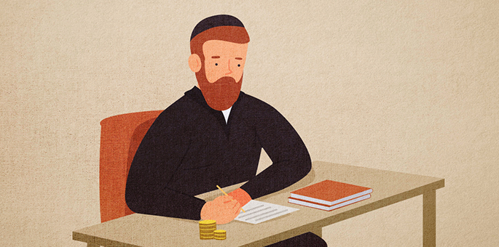
Art by Rivka Korf Studio (Miami)

Almost a year later they had another strange visit—from a posse of Roman soldiers with an order for their arrest. Someone accused them of selling silk without paying the tax to the government. They began weeping and protesting their innocence but to no avail.

Trembling with Fear as They Were Led Off to Prison
Trembling with fear, they were led off to prison where they were given a choice: either pay an outrageous fine of six hundred dinar or produce an even more outrageously priced silk garment for the king, both of which were utterly beyond their means.
When Rabbi Shimon heard what had happened he immediately rushed to the prison and got special permission to visit his relatives.
"Where is the account of the charity you gave?" He asked. "How much did you give?"
"Here," they replied as one of them pulled the small parchment from his pocket.
Rabbi Shimon took the account and noticed that they had given almost six hundred dinar; they were just six dinar short. "Do you have any money with you?" he asked.
They produced six dinar that they had sewn into their garments in case they needed it. Rabbi Shimon took the money, bribed one of the officials, the charges were dropped and they were released.
Rabbi Shimon explained to them what had happened. "This past Rosh Hashanah I dozed off and dreamt that the government would demand of you six hundred dinars. That is why I told you to give charity, to negate the decree."
"Then why didn't you tell us about that?" they complained. "We would have given the money immediately and spared ourselves a lot of anguish."
"But then," replied Rabbi Shimon. "You wouldn't have done the mitzvah for its own sake." (From Midrash Rabbah, Vayikrah 34:12)

Reprinted from the Rosh Hashanah 5781 email of Chabad.Org Magazine.

The Master Key
By Rabbi Shlomo Yosef Zevin

One year, Rabbi Israel Baal Shem Tov said to Rabbi Ze’ev Kitzes, one of his senior disciples: “You will blow the shofar for us this Rosh Hashanah. I want you to study all the kavanot (Kabbalistic meditations) that pertain to the shofar, so that you should meditate upon them when you do the blowing.”
Rabbi Ze’ev applied himself to the task with joy and trepidation: joy over the great privilege that had been accorded him, and trepidation over the immensity of the responsibility. He studied the Kabbalistic writings that discuss the multifaceted significance of the shofar and what its sounds achieve on the various levels of reality and in the various chambers of the soul. He also prepared a sheet of paper on which he noted the main points of each kavanah, so that he could refer to them when he blew the shofar.
Finally, the great moment arrived. It was the morning of Rosh Hashanah, and Rabbi Ze’ev stood on the reading platform in the center of the Baal Shem Tov’s synagogue amidst the Torah scrolls, surrounded by a sea of tallit-draped bodies. At his table in the southeast corner of the room stood his master, the Baal Shem Tov, his face aflame. An awed silence filled the room in anticipation of the climax of the day—the piercing blasts and sobs of the shofar.
Rabbi Ze’ev reached into his pocket, and his heart froze: the paper had disappeared! He distinctly remembered placing it there that morning, but now it was gone. Furiously, he searched his memory for what he had learned, but his distress over the lost notes seemed to have incapacitated his brain: his mind was a total blank. Tears of frustration filled his eyes. He had disappointed his master, who had entrusted him with this most sacred task. Now he must blow the shofar like a simple horn, without any kavanot. With a despairing heart, Rabbi Ze’ev blew the litany of sounds required by law and, avoiding his master’s eye, resumed his place.
At the conclusion of the day’s prayers, the Baal Shem Tov made his way to the corner where Rabbi Ze’ev sat sobbing under his tallit. “Gut Yom Tov, Reb Ze’ev!” he called. “That was a most extraordinary shofar-blowing we heard today!”

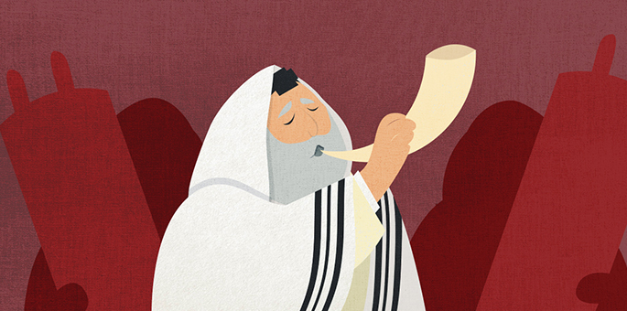
Art by Rivka Korf Studio

“But Rebbe…”
“In the king’s palace,” said the Baal Shem Tov, “there are many gates and doors, leading to many halls and chambers. The palace-keepers have great rings holding many keys, each of which opens a different door. But there is one key that fits all the locks, a master key that opens all the doors.
“The kavanot are keys, each unlocking another door in our souls, each accessing another chamber in the supernal worlds. But there is one key that unlocks all doors, that opens up for us the innermost chambers of the divine palace. That master key is a broken heart.”

Reprinted from the Rosh Hashanah website of Chabad.Org Magazine. Translated and adapted by Yanki Tauber from Rebbi Shlomo Yosef Zevin’s “Sippurei Chassidm.”
Yom Kippur – The Most Wonderful Holiday
By Norma Baumel Joseph

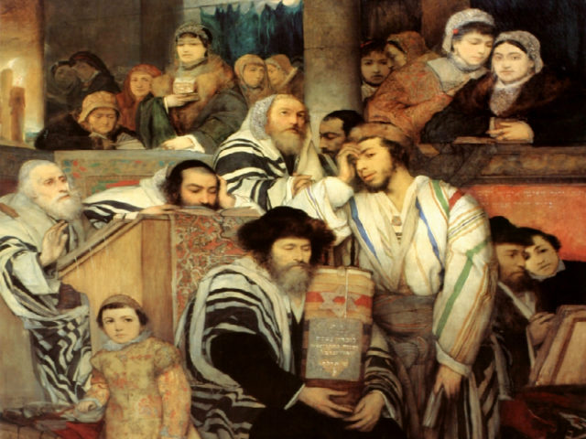Jews praying in the synagogue on Yom Kippur. Painting by Maurycy Gottlieb, 1978 (cropped)

I love Yom Kippur. I know it is a difficult holiday, as the Torah explicitly commands us to suffer on this day. Yet even though I suffer, both spiritually and physically, I embrace the experience with joy. I miss the large family meals that mark all our other celebrations, but I love the prayerful communal binding of this one special day.
When I was a young girl, I treasured being at my grandfather’s side as he blew the shofar, signalling the end of the fast. My father carried me home, and life was good. I didn’t worry about the state of the world, as my little corner of it was fine. I had fasted, sat with my mother, prayed and played. All was good.
But after I got married and had children, a new dimension overwhelmed that sense of self-satisfaction. I had a family to care for and protect. I worried. And I could not stay in synagogue all day. I could neither play nor pray with abandon. Devoted to family, I was elevated in one way and defeated in another. Yom Kippur became a different kind of holiday, no longer one that I could devote to my own enhancement. Rather, I became engrossed in the mundane world of children and their daily routines. I lost the holiness of the day, as I became immersed in the devotion and sanctity of children.
And then my migraines overwhelmed my fasting. For years, all I could think about was the pain, as the caffeine withdrawal left me writhing in migraine hell for days.

Despite the Suffering, It is a Great and Wonderful Holiday
I certainly suffer. But I still maintain that it is a great and wonderful holiday.
The first lesson I learned was to completely decaffeinate early in the season. Additionally, I drink a lot of water. My father taught me to drink seven cups of water right before I light the candles.
Then I prepare for a day in which I can stay in synagogue all day long. I may have to leave for a bit, to take my husband back to his residence. But my preference is to be in synagogue the whole day, immersed in the atmosphere, even with its odours and stuffy air. The encased room becomes a habitat of atonement, a place where it is safe to vent, to expose oneself to God and community, to share one’s past and hopes for the future.
After a while – and it takes time and repetition to get to this stage – one begins to feel at one with the community and with prayer. Slowly and steadily, I build to that feeling. It is ephemeral, hard to hang on to, hard to recognize, but real. This process is available whether we understand the words or not. It is there because of the rigours of the day. No food, no breaks, but lots of physical stimuli. A full day devoted to this process of developing one’s spiritual awareness, of looking deep into one’s life and self-judging. Who am I? Where have I been? Where am I going? How can I do it better?

What a Great Gift this Holiday is
What a great gift this holiday is; what an experience it is to be able to step out of life for a day and get a grip on things. If one is truly devoted to the process, the experience is awesome. There are no guarantees, but the undertaking is surely worthwhile.
At the end, when we all come together, we become a group of individuals who have fasted and prayed and evaluated ourselves, and are now ready to re-enter life. It is this that our songs announce with joy. We sing the closing Neilah prayers with such abandon. I know people are happy because they are going home to eat. But the joy that they exhibit is indicative of more.
Here is a community feeling that shouts: “We did it! We are alive! We fasted and prayed and will make it through another year. We exist and will exist and can continue our traditions!” What a wonderful holiday!

Reprinted from the October 7, 2019 edition of the Canadian Jewish News.

